#Jaccard Similarity
def jaccard_matrix(X):
n = X.shape[0]
J = np.zeros((n, n))

for i in range(n):
for j in range(n):
intersection = np.sum((X[i, :] == 1) & (X[j, :] == 1))
union = np.sum((X[i, :] == 1) | (X[j, :] == 1))
J[i, j] = intersection / union if union != 0 else 0

return J

jac_sim = jaccard_matrix(binary_matrix.values)

jac_df = pd.DataFrame(
jac_sim,
index=binary_matrix.index,
columns=binary_matrix.index
)

print("\nJaccard Similarity Matrix:")
jac_df

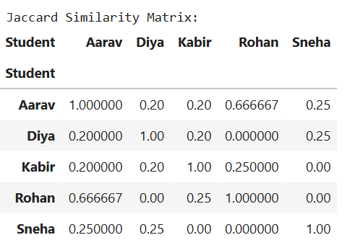

#Case Study: Jaccard Similarity
def jaccard_matrix(X):
n = X.shape[0]
J = np.zeros((n, n))

for i in range(n):
for j in range(n):
intersection = np.sum((X[i, :] == 1) & (X[j, :] == 1))
union = np.sum((X[i, :] == 1) | (X[j, :] == 1))
J[i, j] = intersection / union if union != 0 else 0

return J

jac_sim = jaccard_matrix(incidence_matrix.values)

jac_df = pd.DataFrame(
jac_sim,
index=incidence_matrix.index,
columns=incidence_matrix.index
)

print("\nJaccard Similarity Between Researchers:")
jac_df

